Frat Finance Tracker UI / UX Walkthrough
Here’s a quick walkthrough of the current UI.
Let me know what changes you want to see

VP Dashboard (Landing Screen)
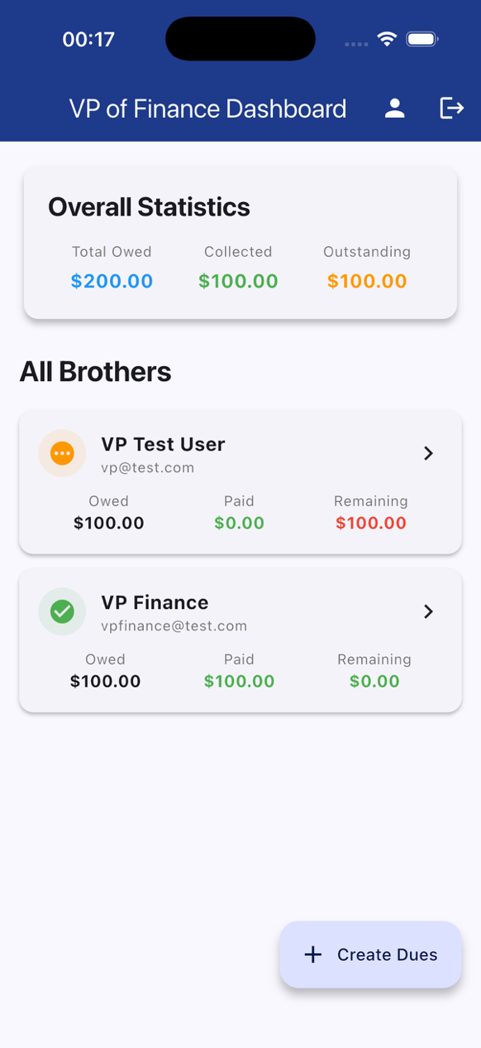
This is the main screen you land on as VP.
The idea is that you can tell:
- How much the chapter owes in total
- How much has already been collected
- How much is still outstanding
Below that is a simple list of brothers so you can quickly see who’s paid and who hasn’t without digging.
Questions:
- Does this give you the info you care about fast enough?
- Anything missing that you’d expect to see right away?

Brother Detail Paid Example
This is the detailed view for an individual brother when their dues are fully paid.
The “Paid” status is intentionally very obvious so there’s no ambiguity.
This is mainly for confirmation and record-keeping.
Questions:
- Is it clear enough that this person is completely done?
- Would you want any extra info here or is this sufficient?

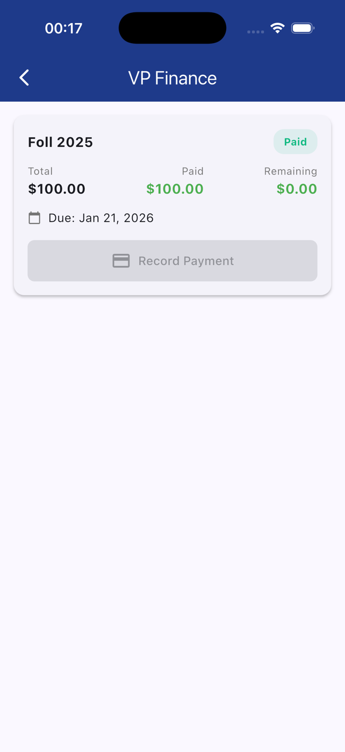

Brother Detail Pending / Unpaid Example
Same screen as above, but showing an unpaid or partially paid state.
The goal is to make it immediately clear how much is still owed and by when.
Questions:
- Is the unpaid state obvious enough?
- Would you want any extra visual emphasis or reminders here?

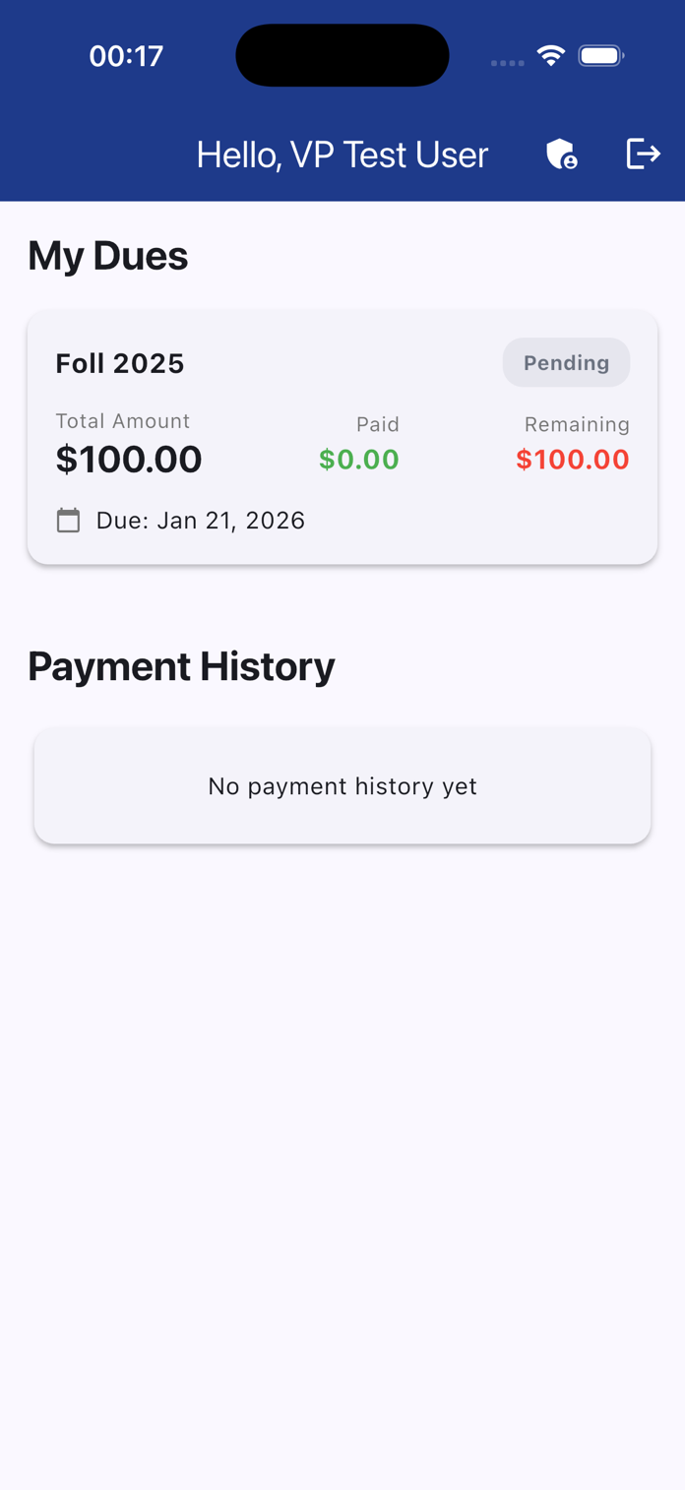

Record Payment
This is the modal for logging a payment.
Only amount and date are required — everything else is optional to keep this fast during meetings.
The goal is that you can record payments quickly without slowing things down. Currently defaults to total dues amount and the current date.
Questions:
- Does this feel fast enough?
- Anything you’d want pre-filled or automated?

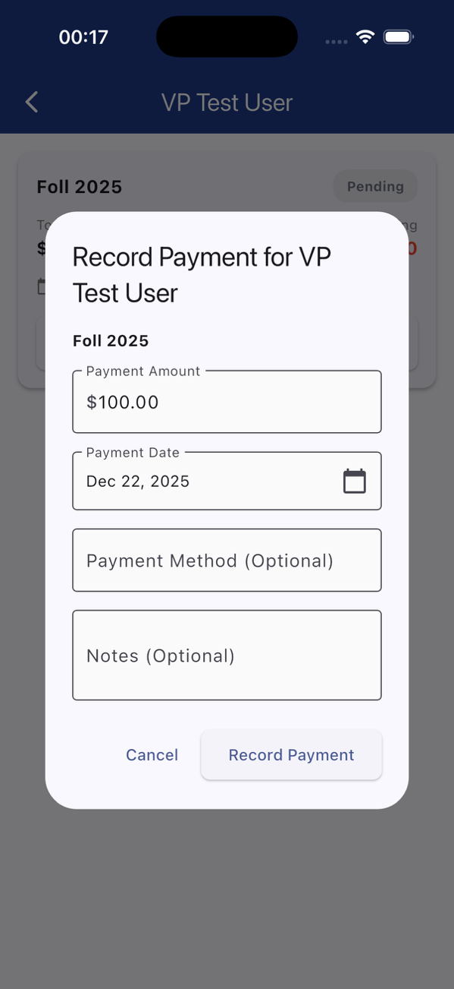

Create Dues Period
This is where you create a new semester or dues cycle.
Everything is intentionally in one place:
- Name of the dues period
- Total amount
- Due date
- Who it applies to
Trying to make this hard to mess up.
Questions:
- Does this feel straightforward?
- Is anything confusing or unnecessary?

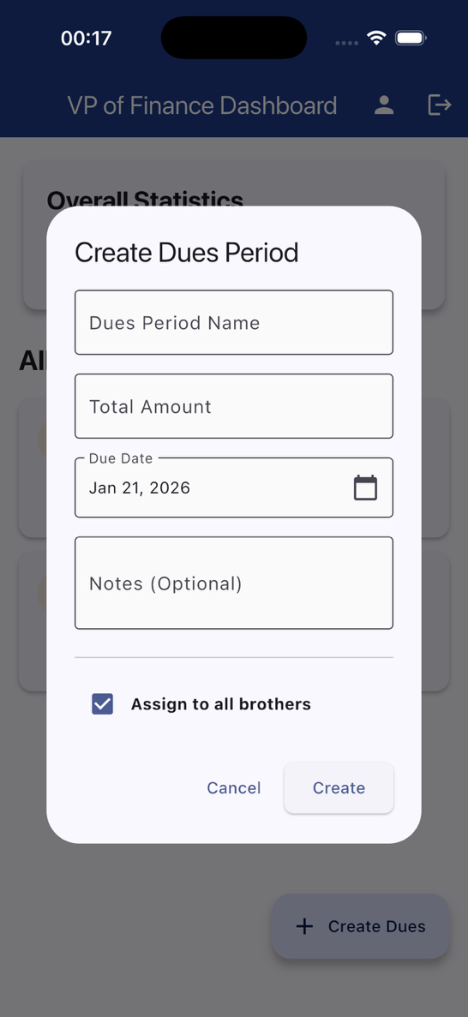

Assign Dues (Everyone vs Select Brothers)
Here you decide whether dues apply to everyone or just specific brothers.
This is mainly about preventing accidental assignments.
Questions:
- Does this give you enough control?
- Would you want a faster default for common cases?

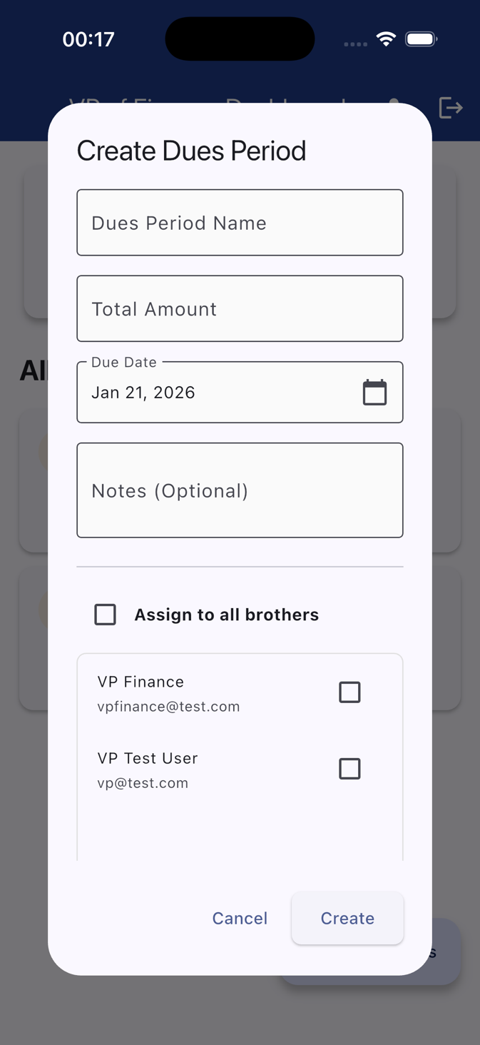

Overall Feedback
- Does the flow match how you’d actually use this as VP?
- Anything confusing, annoying, or missing?
- Any actions you wish were one tap instead of two?

Current state of the project:
For Brothers (Regular Users)

1. Personal Dashboard
- View all assigned dues with status badges (Pending, Partial, Paid, Overdue)
- See total amount, amount paid, and remaining balance for each dues period
- View complete payment history across all dues periods
- Pull-to-refresh to update data
- Due dates clearly displayed with calendar icons
2. Authentication
- Secure login with email and password
- First-time users must change default password immediately
- Automatic logout functionality

For VP of Finance (Admin)

1. Admin Dashboard
- Overall statistics card showing:
- Total amount owed across all brothers
- Total collected
- Total outstanding
- Brother cards showing individual payment status
- Quick view of each brother's total dues, paid amounts, and remaining balance
- Click any brother to see detailed breakdown
2. Dues Management
- Create Dues Periods with:
- Custom name (e.g., "Fall 2024 Dues")
- Dollar amount
- Due date
- Optional notes
- Assign to all brothers or select specific brothers
- Includes VP in brother selection (since VP is also a brother)
3. Payment Recording
- Manually record payments for any brother with:
- Payment amount (with validation)
- Payment date (cannot be future or more than 2 years past)
- Payment method (optional - e.g., Venmo, Cash, Zelle)
- Notes (optional)
- Automatic calculation to prevent overpayments
- Payment Plans Support: Brothers can make multiple partial payments
- Real-time updates after recording payment
- Audit trail: Every payment records who entered it and when
4. User Management
- Create new users (brothers or other VPs) with:
- Email address
- Full name
- Role selection (Brother or VP of Finance)
- Default password: "password123"
- Automatic forced password change on first login
- Users cannot access the app until they change their password
5. Dual View Toggle
- VP can switch between:
- Admin Dashboard (manage all brothers)
- Personal Dashboard (view own dues as a brother)
- Icons in app bar for easy navigation

Security & Data Protection

1. Input Validation
- Amount limits: $0.01 - $100,000
- Date restrictions prevent backdating abuse
- Text field length limits
- XSS prevention (removes HTML characters from inputs)
- Overpayment prevention with 1-cent tolerance for rounding
2. Database Security
- Row Level Security (RLS) policies:
- Brothers can only see their own dues and payments
- VP can see and manage all data
- Audit trails on all records (created_by, recorded_by)
- Authenticated users only (no anonymous access)
3. Error Handling
- User-friendly error messages (no technical jargon)
- All database operations wrapped in try-catch
- Network failure handling with pull-to-refresh
- 5-second display duration for important errors

